Image Gallery Application

# Introduction

Create an image gallery web application which has the following functionalities:

1. Show button: it will display the first image in your gallery
2. Next button: will show the next image each time that is clicked, note that when you are viewing the last image and when you press next button, it must show the first image again in your gallery.

# help

You need to create 2 objects, one for images and one for gallery.

Think about the properties and methods that you need to assign to each object

Gallery.js is for defining all the properties and methods that you need to create your constructor object.

image.js is for defining all the properties and methods that you need to create your constructor object.

App.js is for creating your instances for each constructor object and to add event handlers to each button.

For each image you must display the title of the image followed by the photographer, for instance the first image is New York City – Milad Mirkarimi

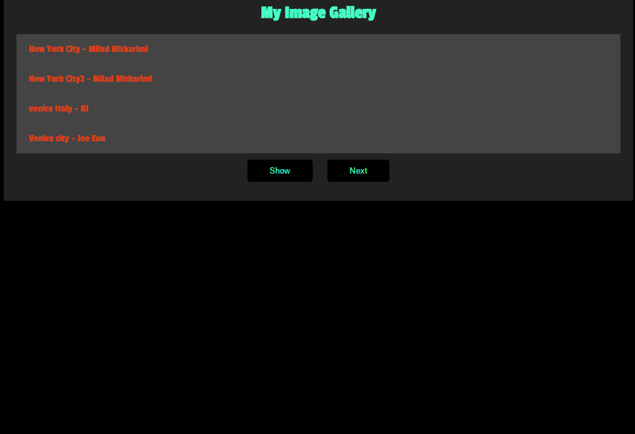

When you click on show button:

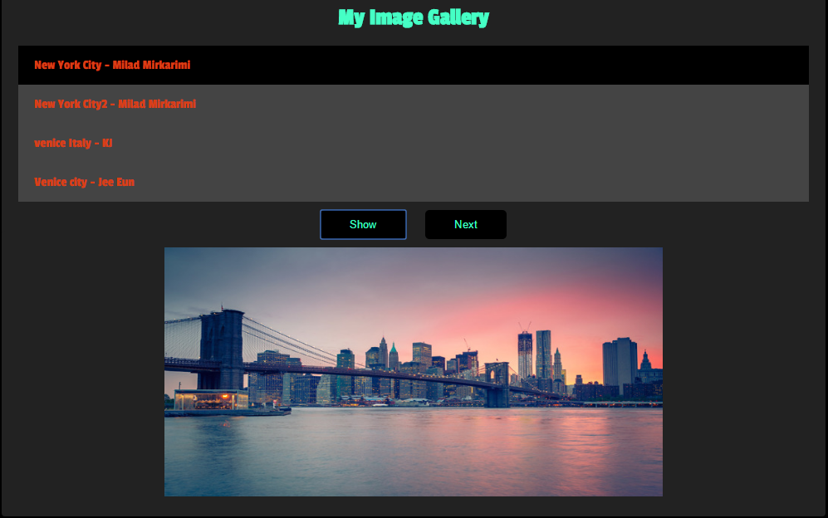

When you click on next button:

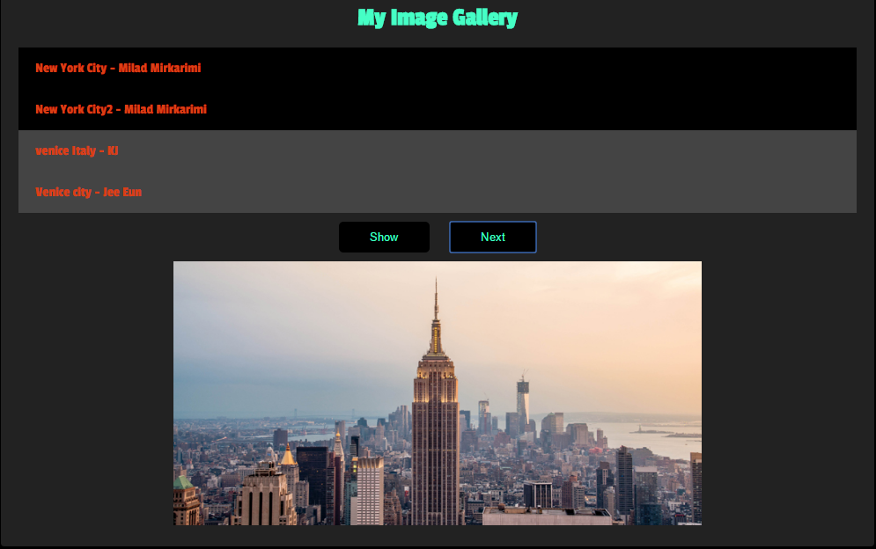

Happy Programming

"There are only 10 types of people in the world: those who understand [binary](https://en.wikipedia.org/wiki/Binary_numeral_system), and those who don't."